Walkthrough 16 Dialogs and Fragments

https://sapui5.hana.ondemand.com/#/topic/4da72985139b4b83b5f1c1e0c0d2ed5a

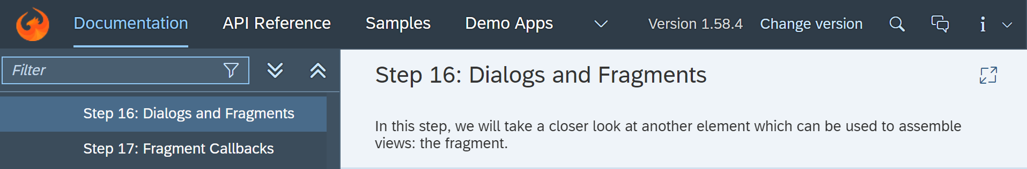

Core Changed Codes Compared to Last Version:

HelloDialog.fragment.xml【New】

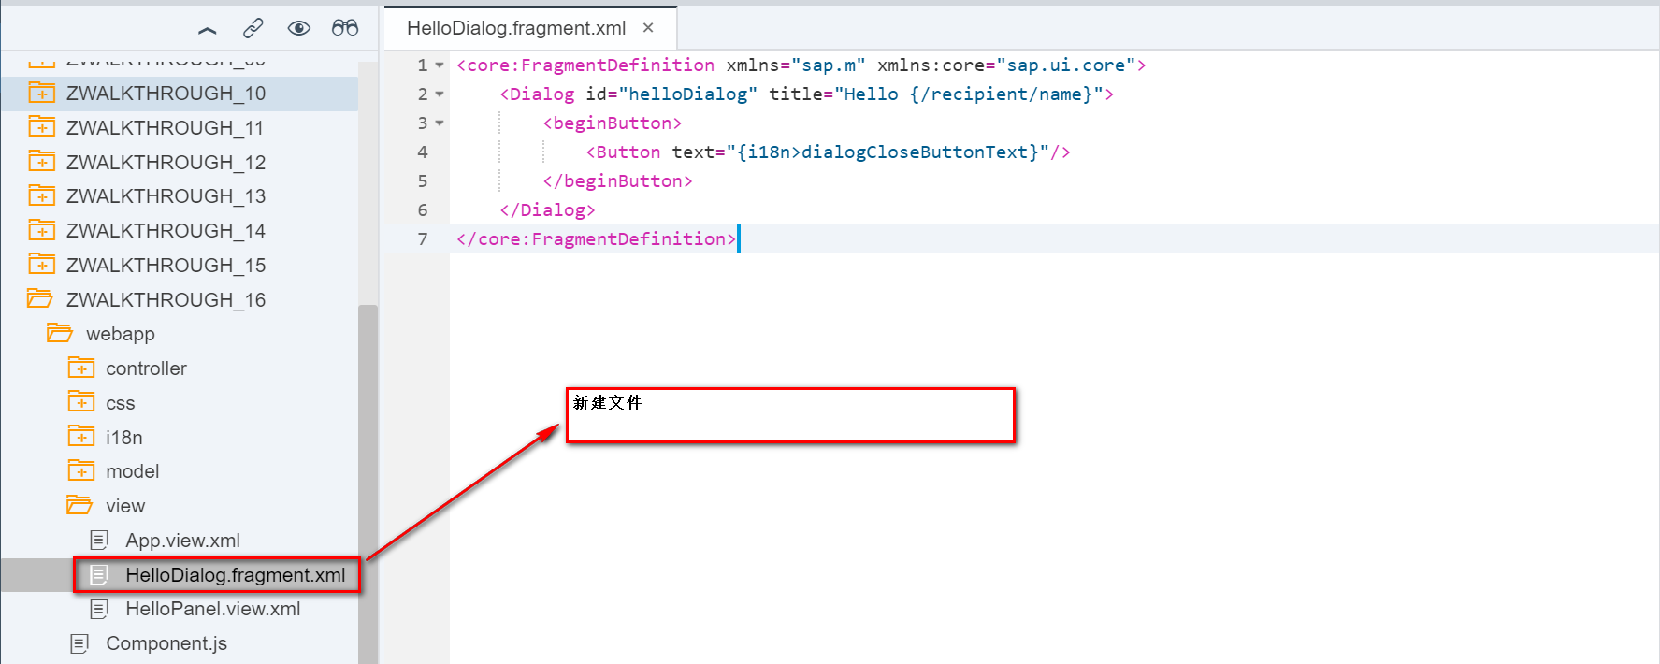

HelloPanel.view.xml【Update】

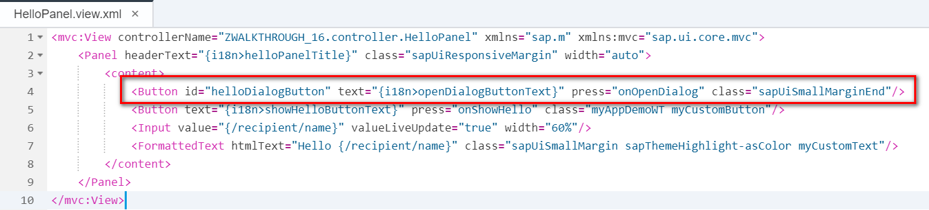

HelloPanel.controller.js【Update】

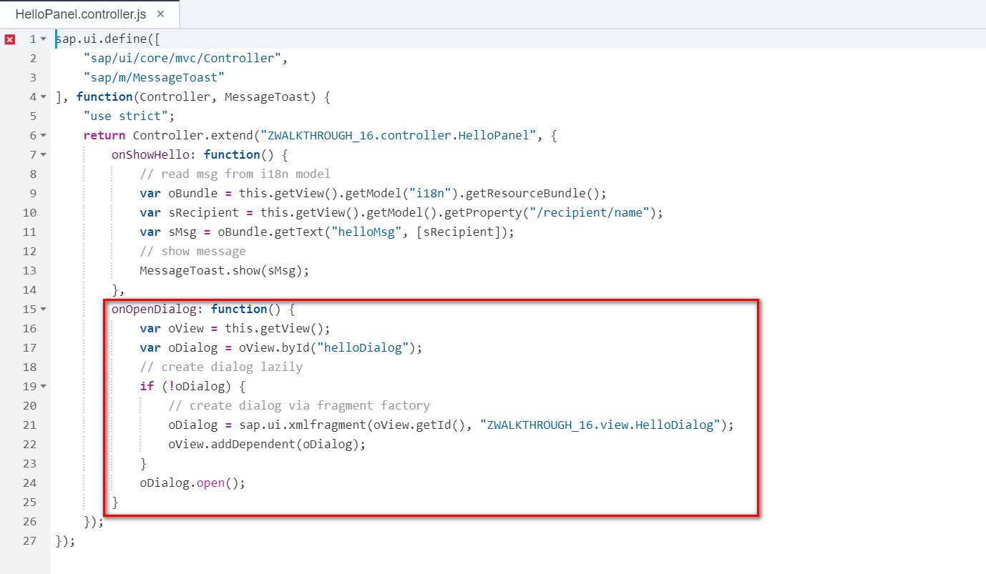

I18n【Update】

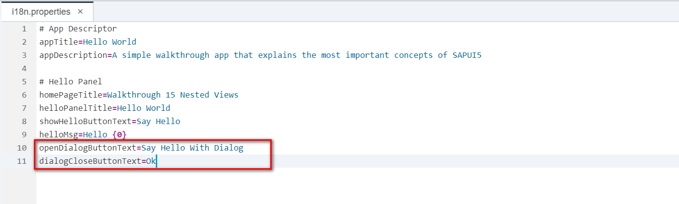

Result:

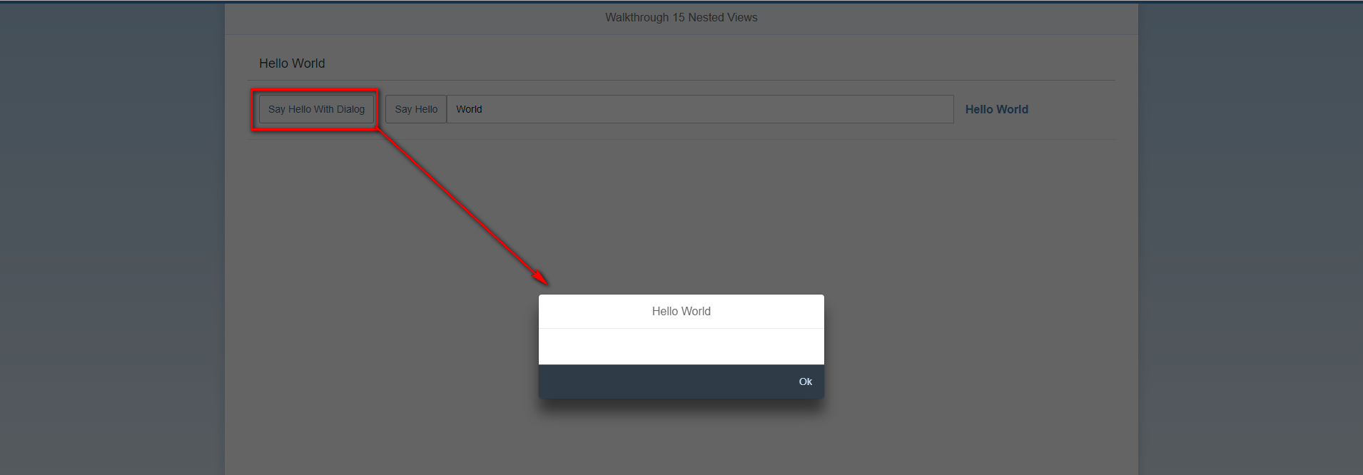

Git:

https://github.com/xiexiaop/SAPUI5-2-Round/tree/master/Projects/ZWALKTHROUGH_16

2018/11/09 XiaoMi Beijing Zac,Xie